

**Name:** Abdul Rehman

**I.D:** F2019065253

**Subject:** Open Source Software Development

**Section:** W1

**Submitted to:** Muhammad Asad Arshed

**Assignment # 2**

**How logical address map with physical address?**

Logical address map with physical address by a hardware device call Memory-Management Unit.

MMU generates identical logical and physical address during compile time and load time but during run time the MMU generates different logical and physical address.

This can be further explained by following diagram:

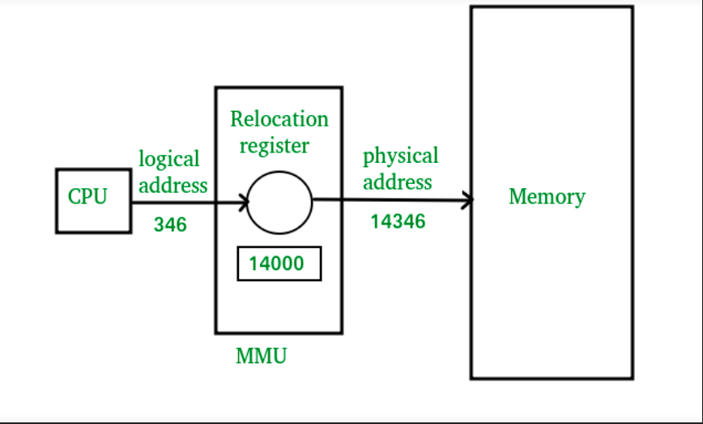

Here:

1: CPU will generate logical address for example: 346

2: MMU will generate a relocation register (base register) for example: 14000

3: In memory, the physical address is (346+14000 = 14346).

The value in the relocation register is added to every address generated by a user process at the time the address is sent to memory.